

**FOOD ORDERING APPLICATION REPORT**

**Report 3 – Software Requirement Specification**

– Hanoi, January 25, 2021 –

**Table of Contents**

I. Project Report 4

1. Status Report 4

2. Team Involvements 4

3. Issues/Suggestions 4

II. Software Requirement Specification 5

1. Overall Description 5

1.1 Product Overview 5

1.2 Business Rules 6

2. User Requirements 7

2.1 Overview 7

a. Use Case Diagram 7

b. Entity diagram 9

3. Functional Requirements 9

3.1 System Functional Overview 9

a. Screen Flow 10

b. Screen Details 10

c. Entity Relationship Diagram 12

3.2 Mock Up 12

a. Landing page 12

b. Search Page 13

c. See all page 14

d. Promotion page 15

e. Check Out Page 15

f. Final Review page 16

g . Write Review page 16

h . Order overal page 17

i . Order detail page 17

3.3 Prototype 18

a . Splash screen –Sign in –Log in 18

18

b . Landing page 19

c . Promotion page 20

d . Search page 22

e . Detail page 22

e . Check out page 23

f . Write review page 26

# I. Project Report

## 1. Status Report

|  |  |  |  |
| --- | --- | --- | --- |
| **#** | **Work Item** | **Status** | **Notes( Work Item in Details)** |
| 1 | Description | Completed |  |
| 2 | Context diagram | Completed |  |
| 3 | Use case diagram | Completed |  |
| 4 | Use case description | Completed |  |
| 5 | Bussiness rule | Completed |  |
| 6 | Entity diagram | Completed |  |
| 7 | Mock-UP | Completed |  |
| 8 | Prototype | Completed |  |

## 2. Team Involvements

|  |  |  |  |
| --- | --- | --- | --- |
| **#** | **Task** | **Member** | **Notes( Work Item in Details)** |
| 1 | Description | Phuc NH |  |
| 2 | Context diagram | Đăng |  |
| 3 | Use case diagram | Thanh DC |  |
| 4 | Use case description | Completed |  |
| 5 | Bussiness rule | Huy Anh |  |
| 6 | Entity diagram | Thanh DC |  |
| 7 | Mock-UP | Phuc NH |  |
| 8 | Prototype | Phuc NH |  |

## 3. Issues/Suggestions

|  |  |  |  |
| --- | --- | --- | --- |
| **#** | **Issue** | **Status** | **Notes (Solution, Suggestion, etc.)** |
| 1 |  | Pending |  |
| 2 |  | In Progress |  |
| 3 |  | Completed |  |

# II. Software Requirement Specification

## 1. Overall Description

### 1.1 Product Overview

The most popular and developed online food ordering applications today such as Grab Food, Now, Baemin,... However, these applications only focus on operating in big cities without developing in the suburbs like Hoa Lac, which makes FPT students at the Hoa Lac campus face many difficulties in ordering food online.

So, in this project, we will make a phone application called CocDoi – an application built to solve the ordering food issues for FPT Students at Hoa Lac Campus. The purpose is to help students and restaurants easily approach each other by studying the needs and difficulties of students as well as restaurants in order to develop software with many convenient features to serve the needs of users.

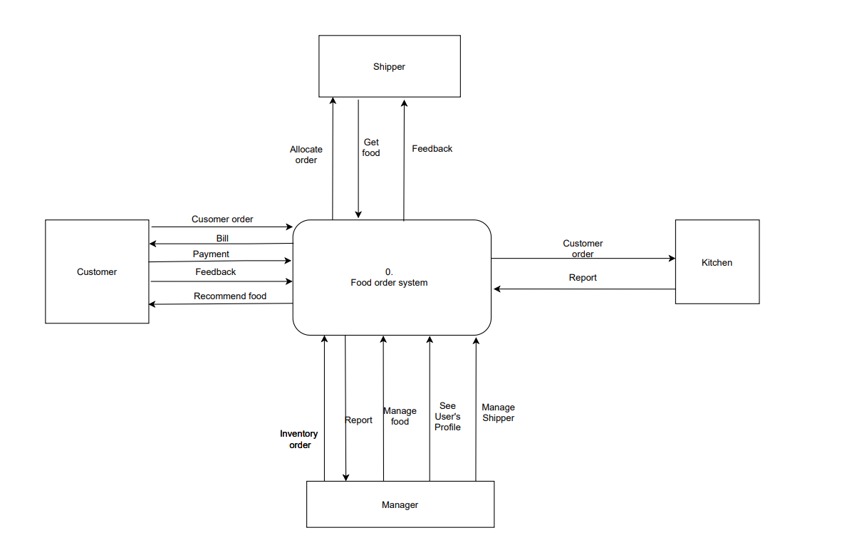

The expected result of the product is a complete mobile application with the most important task: to be a technology platform to support restaurants in connecting with customers, helping restaurants to increase revenue and brand value, as well as providing customers with a variety of reliable and diverse choices. To achieve this purpose, the application will include the following key features:

● Restaurant information display feature.

● Ordering, sending orders features.

● Searching for food and restaurants by keyword.

● Suggestion feature, restaurant introduction.

● Sign up / login feature.

● Post review and comment feature.

● Restaurant calling feature.

### 1.2 Business Rules

|  |  |  |
| --- | --- | --- |
|  | **ID** | **Description** |
| Customer | C01 | Log in properly, password is secure enough. |
| C02 | Register an honest name, avoid confusion when delivery. |
| C03 | Customers can choose 1 of 2 payment methods including "bank card (linked to bank account), and payment by cash. |
|  | C04 | Order confirmation upon receipt. |
|  | C06 | Responsible for the order. |
|  | C07 | Give feedback for the service. |
| Shipper | S01 | Work on time, ensure working status during working time. |
| S02 | Ensure there are enough and equipment for the job. |
| S03 | Delivery to the correct address. |
| S04 | Compare order codes when delivered to customers. |
| S05 | Ensure the quality of the product to the customer. |
|  | S06 | Have fair treatment and professional ethics. |
|  | S07 | Efficient order management. |
| Kitchen | K01 | Efficient order management. |
| K02 | Stay online during opening hours. |
| B03 | Quality assurance of food. |
| B04 | Read carefully and follow customer notes. |
| B05 | Complete the product as soon as possible, if there is a problem, it must be reported to the customer. |
|  | B06 | Kitchen must be responsible for refunding or redoing the order if the food is not of the right quality? |
|  | B07 | Carefully check the number of dishes and make notes before delivering to the shipper. |

## 2. User Requirements

### 2.1 Overview

#### a. Use Case Diagram

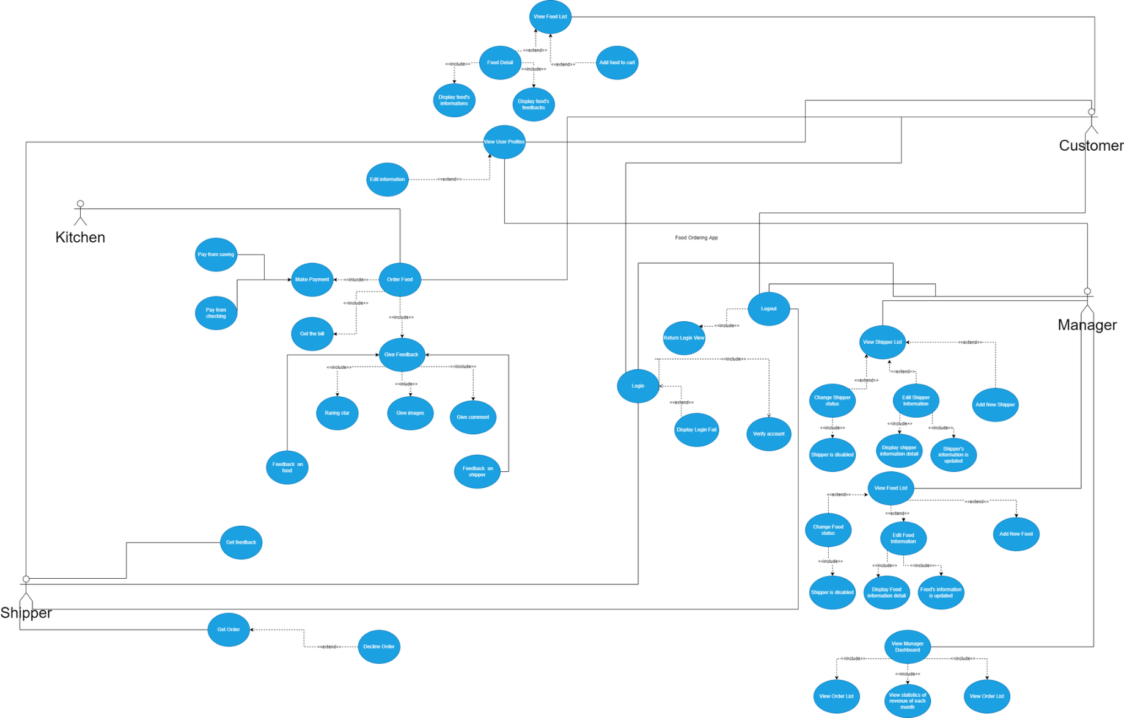

#### b. Entity diagram

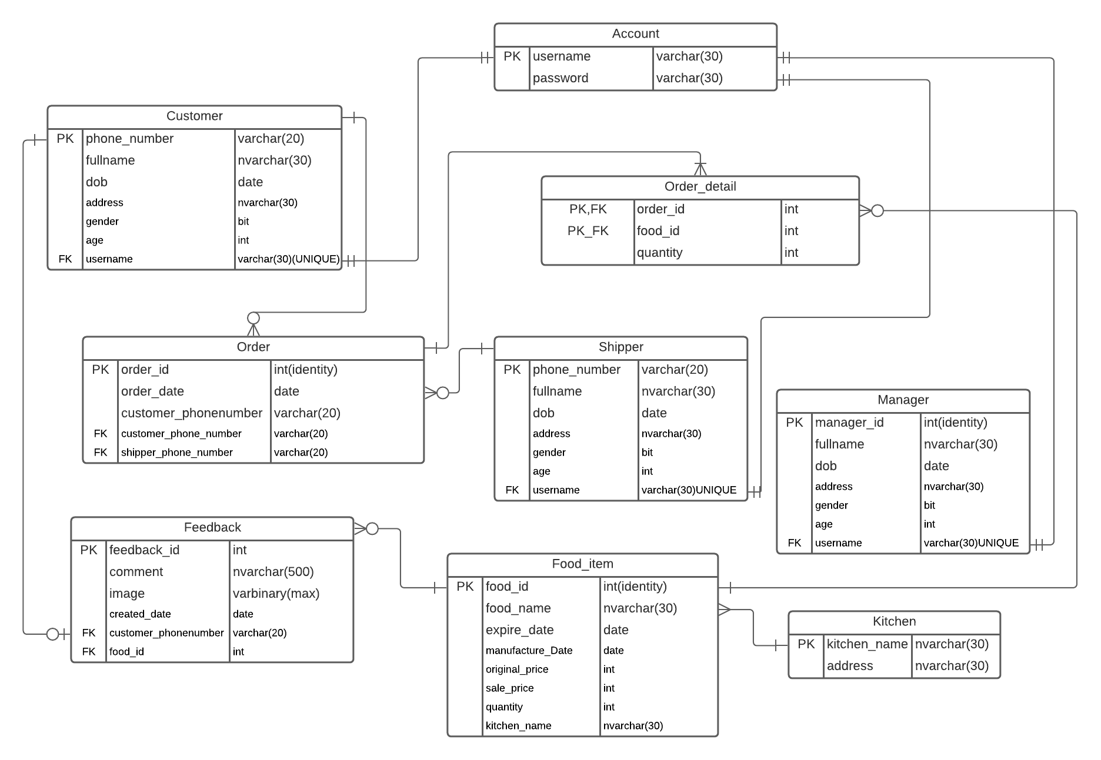

## 3. Functional Requirements

### 3.1 System Functional Overview

#### a. Screen Flow

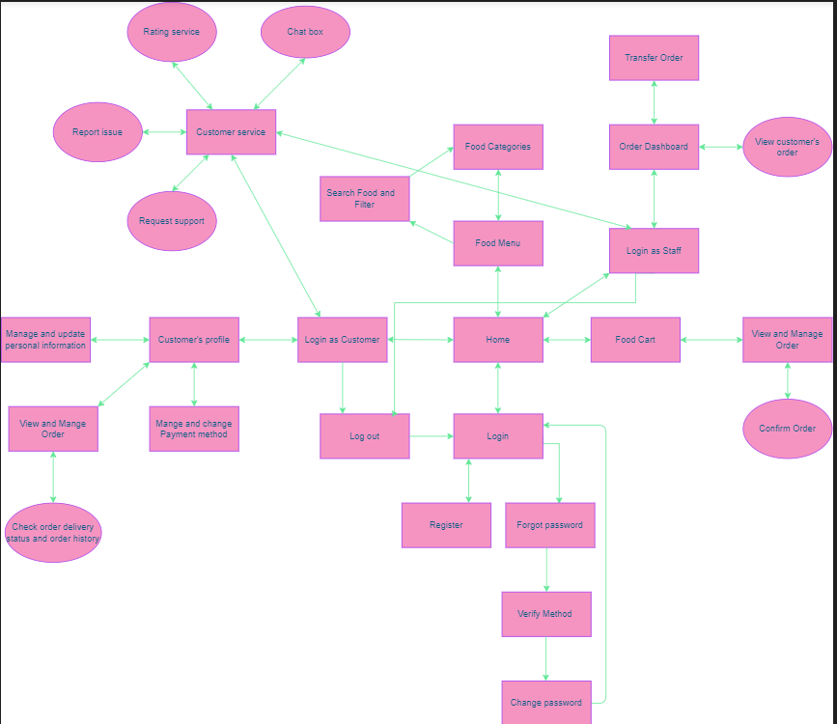

#### b. Screen Details

|  |  |  |  |
| --- | --- | --- | --- |
| **#** | **Feature** | **Screen** | **Description** |
| 1 | Home | Splash Screen | Screen to display the logo of the company |
| 2 | Home | Log in Screen | Screen for the user to log in the system |
| 3 | Home | Sign in Screen | Screen for the user to sign in the system |
| 4 | Home | Forget password | Screen for the user to find their password |
| 5 | UserProfile | Landing Screen | Screen to display a list of famous restaurants within the area, also today’s offer, promotions. |
| 6 | User Profile | See All Screen | Screen to display every restaurant |
| 7 | User Profile | Search Screen | Screen for the user to search for food/restaurant base on keywords |
| 8 | User Profile | Promotion Screen | Screen to display all the promotion that currently valid, coupons and every restaurant offer discount |
| 9 | User Profile | Restaurant Detail Screen | Screen to display detail of the restaurant that the user click on, includes name of restaurant, type of food, menu, images, opening time, distance from the user |
| 10 | User Profile | Item Detail Screen | Screen to display the price of the item that user choose, includes description of the item ( mô tả món ăn, số calor trong món ăn), user can choose the quantity of the item then add to basket |
| 11 | User Profile | Review Restaurant Screen | Screen to display all comments and review from user |
| 12 | User Profile | Add Review Screen | Screen for user to rate restaurants, upload images and comments for the restaurant |
| 13 | User Profile | Checkout Screen | Screen for the user to confirm the order, check delivery information, quantity of item |

#### c. Entity Relationship Diagram

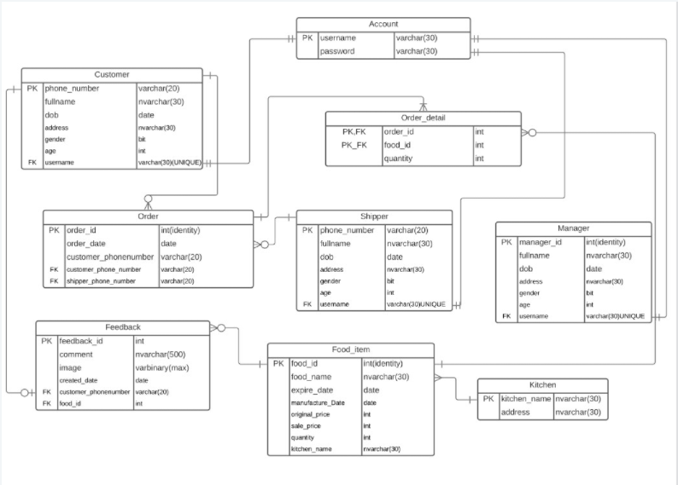

### 3.2 Mock Up

#### a. Landing page

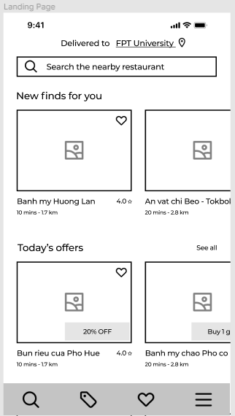

#### b. Search Page

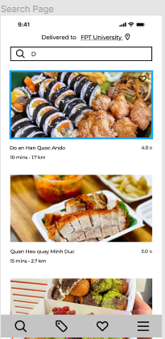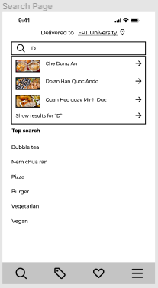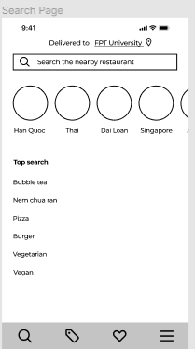

#### c. See all page

#### d. Promotion page

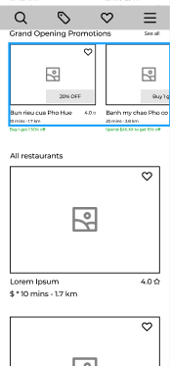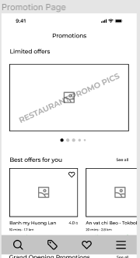

#### e. Check Out Page

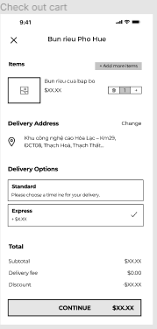

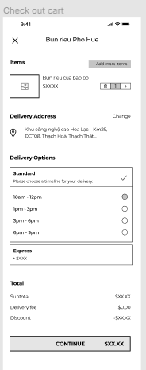

#### f. Final Review page

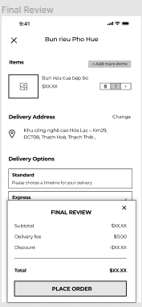

#### g . Write Review page

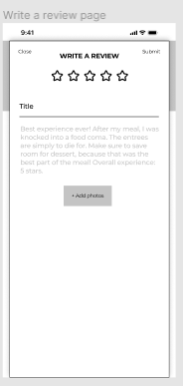

#### h . Order overal page

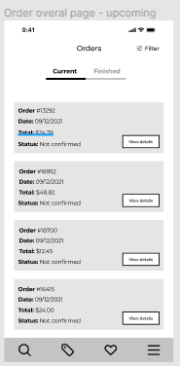 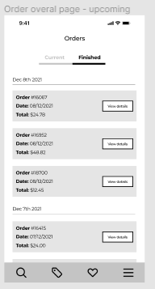 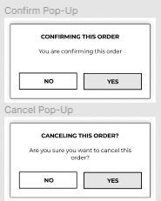

#### i . Order detail page

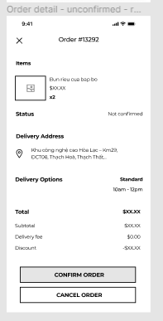 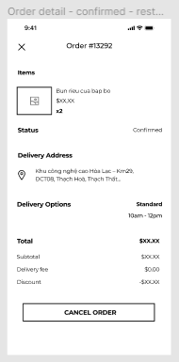

### 3.3 Prototype

#### a . Splash screen –Sign in –Log in

#### 

#### 

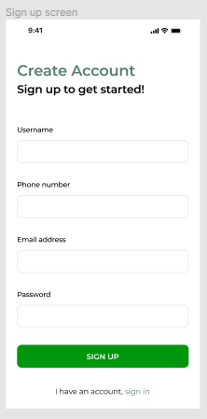 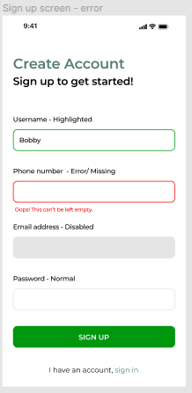

#### b . Landing page



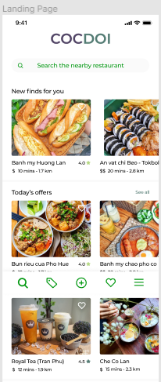 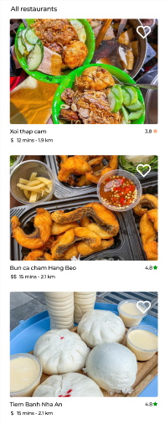

#### c . Promotion page



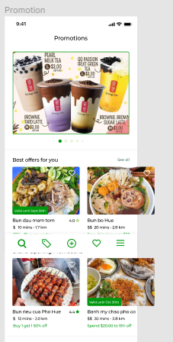

#### d . Search page

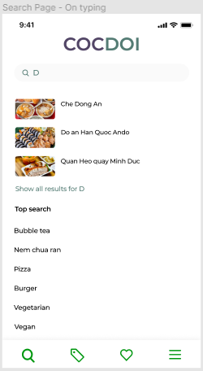

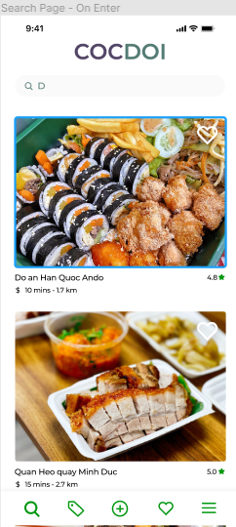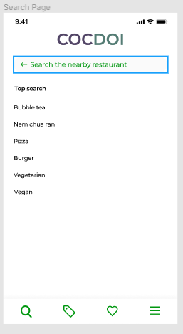

#### e . Detail page

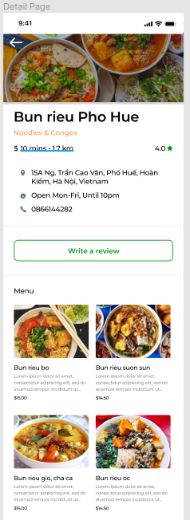 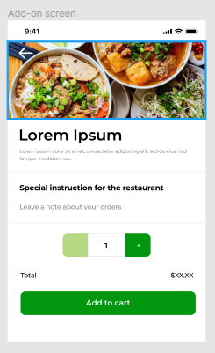 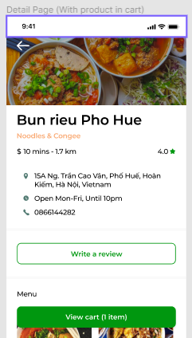

#### e . Check out page

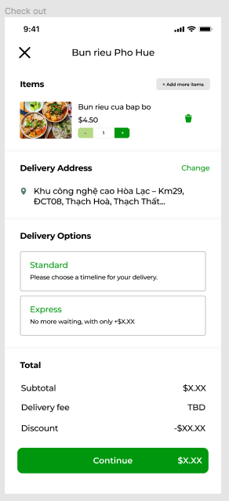 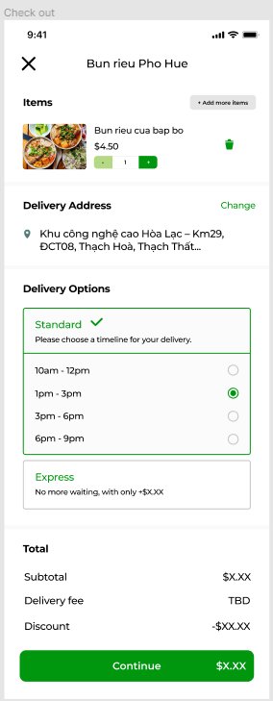

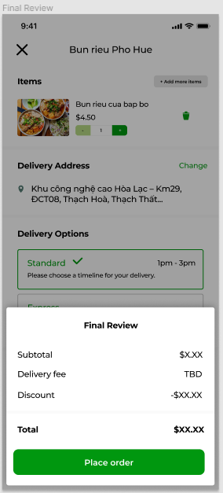 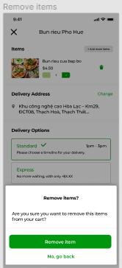

#### f . Write review page

